Tubing Applications for the connection lab equipment When selecting piping and tubing for connecting lab equipment please consider.

1 Lab environments are not always a perfect 72 degrees. It is not uncommon for a chiller failure to occur resulting in temperatures rising to the mid-90s or even higher in some cases. Temperature rating of pipes and tubes should consider a worst case scenario.

2. Consider the worst case pressures and temperatures of the material inside the pipe or tubing.

3. Ensure the tubing is appropriate for the material being used. An example would be using copper tubing for Hydrogen gas although the copper is capable of holding the pressure over time the Hydrogen will cause the copper to become brittle. Movement of the copper line or vibrations in the room can then create a leak.

4. Equipment in high vibration areas may result in leaky connections over time. In such case use only the highest quality materials installed by the best qualified personnel.

5. In high risk areas or areas that are directly connected to the building supply of water consider the installation of a water sensor and auto shut off valve.

6. Consider a point of use water source for supplying equipment cooling water.

7. Always provide a pressure relief to protect the lowest rated system component. The relief devise should be directed away from lab users preferably into an exhausted area.

8. The selection of tubing is vast thusly not all are listed here. If questions or doubts arise ask your supervisor or mentor for assistance. Training can be arranged through your department.

9. All tubing and parts to be used for Oxygen delivery should be cleaned, packaged and sold for Oxygen use.

**Stainless steel tubing**.

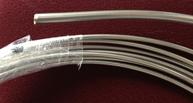Acceptable for use with Inert gases, flammable gases, compressed air, lab water, house vacuum systems Coiled stainless tubing is available in most common sizes used in labs it would be suitable where a little flexibility in equipment footprint is desired.

For high purity applications can also be purchased in 20 foot straight lengths which are lapped, polished, and shipped bagged in nitrogen. The ¼ diameter with 0.035 wall thickness is standard for orbital welding and VCR fittings. Two vendors are Valex Corp, Allentown, PA and Raleigh Valve and Fittings.

**S series tubing**

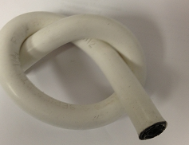PFA Core Hose 302 SS Braid Reinforced Acceptable for use with Inert gases, flammable gases, compressed air, lab water, house vacuum systems. S series hosing and connectors offer pressure rating up to 3500psi. Hose can purchased in bulk (special tools are required to assembly end connectors) or can be made to order by the supplier with the users’ choice of end connectors.

**Copper tubing**

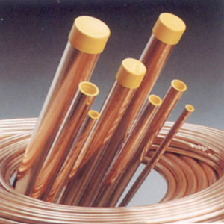 Acceptable for use with Inert gases, compressed air, lab water, house vacuum systems.

The copper tubing usually supplied is for plumbing applications and is not clean, i.e. has hydrocarbon contaminants. This is the primary source of contamination in the RB1 compressed air system. Can be purchased cleaned. Can also be brazed with a fluxless gas source. For use in vacuum, expecially if it gets hot use HCOF (high conductivity oxygen free) copper. The OCOF does not contain sulfur and is more dimensional stable.

**Swagelok or Parker Push on hoses** or equivalent

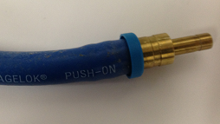 Acceptable for use with Inert gases (some lighter gases may permeate the hose), compressed air, lab water, house vacuum systems. Push on hoses are rated to 350psi when used with the manufactures barb connector, sizes 3/8 and smaller require no special tools to assembly. Tubing can be obtained in many colors. For barbed fittings with a cap that goes over the OD of the tubing hose clamps weakens the seal. A tool for inserting the barbed fittings is available.

**Polyurethane tubing**

Small 1/8” OD tubing is good for compressed air lines that require low flow rates such as most valves. Tubing comes in many colors for ease of identification. Reliable, quick disconnect and barbed connections available. Local vendor is Motion Industries of Raleigh. Cost less then $20/10 meter length.

**Reinforced Tygon tubing**

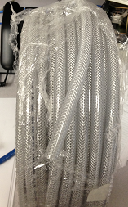 Acceptable for use with Inert gases, compressed air, lab water, house vacuum

With the correct barb connectors and band clamps a good choice for connecting to lab glass ware where a pressurized system is required.

**General use Tygon tubing**

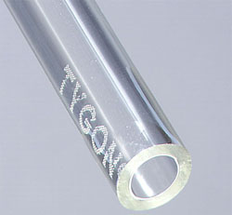 Acceptable for use with Inert gases, compressed air, lab water. This tubing should never be used to contain pressure or in a system where a valve could be closed isolating the tubing to a pressure source. It is only design as a flow though median. When used to supply water it should be in an area where a drain is open and available in the event of a rupture or disconnect for example in a sink or a chemical hood with a drain that is clear and open and its operation have been tested and verified.

**General use Tygon tubing**

 Tygon tubing should never be used in a closed or pressurized system regardless of the median or a system where a valve could be closed isolating the tubing to the pressure source. **If used with water it will burst in the future.**

**PVC piping**

Should never be used to supply pressurized gases or air