Hf Requirements for users and for rooms
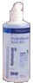 | If you don’t think  500 mL is enough  to kill a person by
dermal exposure, think again.
It’s deadly.
revised March 2007. Available at http://www.chem.purdue.edu/chemsafety/Chem/HF.doc

Call it HF. Because
hy-dro-fluo-ric sounds just like hy-dro-chlo-ric.
To most people. The distinction is critical.

Before any HF use occurs:
1. All people who will be in the room while HF is in use must have completed training. File a training documentation form signed by the trainee and by the supervisor noting the date, topics, duration and manner of assessment of the training.

2. All first aid supplies must be acquired, labeled properly, dated, and assembled in the work area. See reverse side or second page for requirement (they are somewhat quantity and concentration dependent).

3. Information must be posted prominently
a. signs identifying the location of all HF first aid supplies, including
[ ] calcium gluconate prep(s)
[ ] benzalkonium chloride prep(s)
[ ] towels/gauze for soaks
[ ] basin(s) for soaking
[ ] nebulizer
[ ] spray bottle
[ ] other…

b. first aid and medical treatment instructions and MSDS(s) for all types of HF present (available as laminated poster from REM)

c. instructions for emergency procedures, including first aid steps, emergency phone number(s), and exactly what instructions and printed materials are to be given to the emergency responders.

d. all written rules for PPE, safety equipment, and SOP.

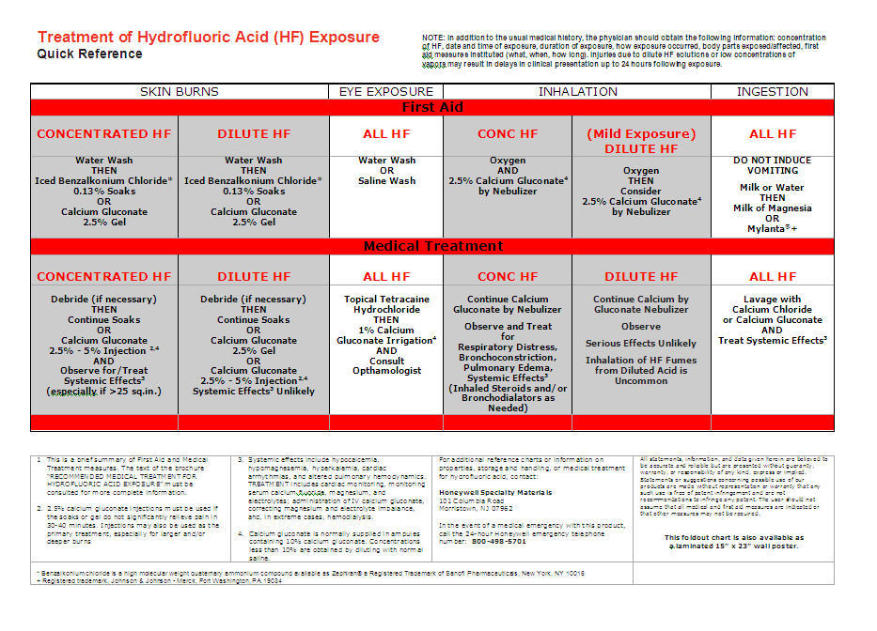 in the HF work area, including
-- page 1 of 2 --

A. Concentrated or anhydrous HF
In any work area where any quantity of HF in concentration ≥40% is to be used, the required first aid supplies are

- benzalkonium chloride 0.13% aqueous solution (BA_{(aq)}), refrigerated, minimum two gallons
- basin/dishpan/bowl for soaking body part
- gauze/towel soaks
- calcium gluconate, 2.5% in surgical lubricant or KY jelly
- calcium gluconate, 2.5% in sterile water, sterile container (for nebulizer)
- electric nebulizer
- two minute availability of ice cubes for soaking container and solution
- OXYGEN
In all use areas there must be a shower and hands-free eyewash *in* the room.

B. Moderate concentration HF

Where HF ≥5% but <40% is used or stored in any quantity, the first aid requirements are as in A above with these changes:

- BA_{(aq)} only 1 gal minimum required
- Nebulizer NOT required
- sterile water solution of calcium gluconate (for nebulaizer) NOT required
- Oxygen not required unless heating HF.

C. Low concentration HF

Where HF <5% is used, the first aid supplies requirements are:

- calcium gluconate, 2.5% in surgical lubricant or KY jelly

Create labels for gluconate and benzalkonium chloride supplies which look like this, and keep them complete and correct at all times. Discard and replace supplies as stated.
Calcium gluconate %
Mixed into
Date prepared
By
Keep in
Room
Discard on
(replace with new preparation after 6 mo)

Constant gentle massage is recommended until and after medical help arrives.
Benzalkonium Chloride %
Mixed into
Date prepared
By
Keep in
Room
Discard on
(replace with new preparation after 1 year)
!!NOT FOR USE IN EYES!!
Soak skin in basin, and use fabric/gauze compresses, until medical help arrives.
0.13
Deionized water
Refrigerator _____
-- page 2 of 2 --

