Approved flamm storage = safety cans and flamm cabs.

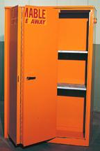
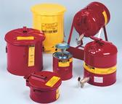
They must be working properly and cannot be cut into. Cabinets are not vented except by special permission of Fire Safety.

There may be NOT MORE THAN 10 gallons combined Class I plus Class II liquids OUTSIDE of approved flammable storage in a "fire area." (A fire area is separated from other areas by fire doors. We usually use "room" as the unit, rather than fire area.)

Doors are to be self-closing and equipped with a latch

COMBINED CLASS I AND CLASS II LIQUIDS:
Flash point <38 ºC and bp < 60 ºC. EXAMPLES

1-butanol
1-propanol
2-butanol
2-propanol
acetic acid
acetone
acetonitrile
benzene
diethyl ether
dimethylformamide
ethanol
ethyl acetate
heptane
hexane
isopropyl alcohol
methanol
methyl ethyl ketone
n-heptane
n-hexane
n-nonane
n-octane
n-pentane
p-dioxane
pentane
propionic acid
propylene oxide
tetrahydrofuran
toluene
xylenes

