Dispose of chemical containers correctly

These containers can be regarded as legally empty if they can be turned upside down and nothing drips out the top.

!!!!BUT, they cannot go in the trash that way!!!!

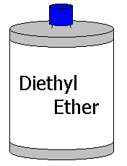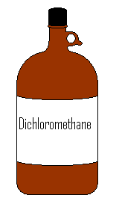
A container which is legally empty but contains residual volatile solvent may be “air dried” in a chemical hood.

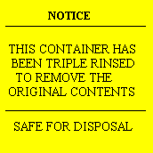
In all cases these rules must be followed:

1. Remove cap, throw away separately.
2. Put “safe for disposal” sticker on the container.
3. Container must be ODORLESS and not wet with anything except water.
4. Toxic residue must be washed or rinsed out.

Then it can go in some direction toward the regular trash :
metal cans – in the wastebasket.
ODORLESS means no smell. No acetone, no ether, no ANYTHING. No smell. Very simple.

