X-ray Crystallography 12650 - CHM 69600-006

Homework Assignment 1:
Miller Planes and Braggs’ Law

Question 1 and 2 are fifteen points, question 3 twenty points. Due date: One week after assignment.

1)
Index the following Miller planes. The shown unit cells are cubic. Assume the directions x, y and z to be the directions of the a, b and c axes.
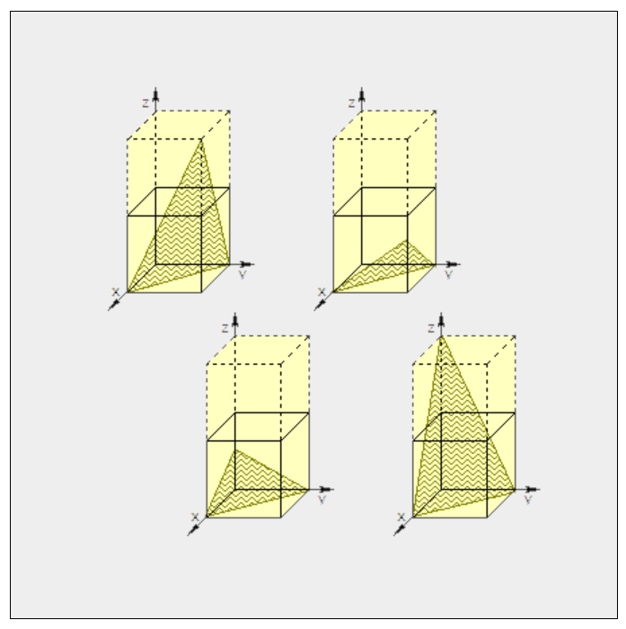
For all four planes, what is the d-spacing for the Miller planes (as a multiple of the unit cell axes a, b and c, which are identical for a cubic unit cell).
2)
Have a look at the depiction below. Is it an accurate representation of a crystal in diffraction condition as defined by Braggs’ law? Explain your choice.

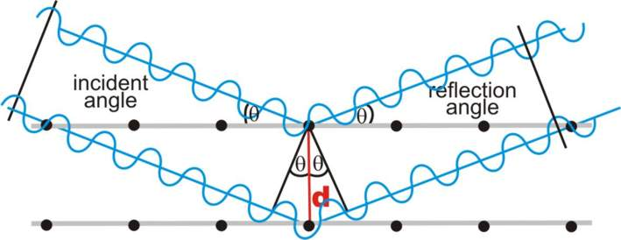

3)
Assume the sketch below to be the first order (200) “reflection” of a cubic crystal.
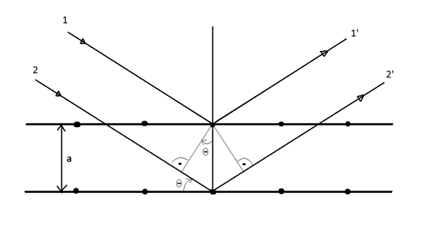

What is the diffraction angle θ of the (1 0 0), (2 0 0) and (3 0 0) reflection as a function of the unit cell axis a and wavelength λ?

A pencil and two rulers are needed for the following two exercises:
Print out or copy the image and add “the waves” with wavelengths and the path length difference (to hand drawn accuracy).
Make a similar sketch for the (1 0 0) and the (3 0 0) reflection on the same scale (feel free to copy or print out the above drawing). Add d-spacing, path length difference of the waves, θ, and two constructively interfering beams (with waves and wavelength drawn hand accurate) for the (1 0 0) and the (3 0 0) reflection.

Using Bragg’s law, what is the d-spacing of the (1 0 0), (2 0 0) and (3 0 0) reflection as a function of the unit cell axis a?

