X-ray Crystallography 12650 - CHM 69600-006

Homework Assignment 2:
Unit cells, translational and point symmetry
“Christmas Crystallography”

Each question (1-5) is fifteen points. Due date: One week after assignment.

Crystallographers have to be efficient. Especially just before the Holidays. Cutting out cookies the usual way leaves leftover dough, and rolling it out a second or third time just won’t do. And there is only so much space on the cookie tray and in the oven!
Let’s prepare for next year. How would you cut the cookies to leave the least dough left unused? Square or rectangular shapes would work of course, but rectangles for Christmas?
Here are four different Christmas cookie shapes: A star, a bell, a Christmas tree and an angel.
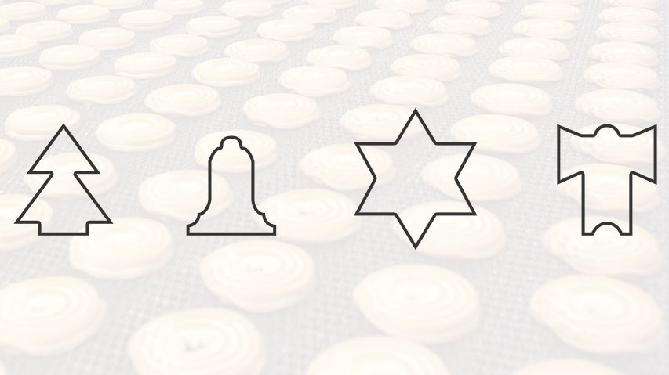

- Which of these can you arrange into a two dimensional (“plane”) lattice without leaving any space in between? Please make a drawing of each with enough individual shapes to unambiguously show their two-dimensional arrangement (drawings can be hand-crafted, computer generated, or a combination of both).
Can one or more of these structures not be arranged into a regular two dimensional lattice that leaves no space between shapes? If this is the case, explain why.
Can any of the examples be arranged in more than one way? If this is the case, include the two “most symmetric” arrangements that are not identical.

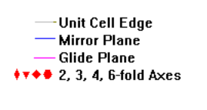
- In a second drawing, please add the boundaries of the unit cell as well as any symmetry elements. Please use the symbols shown to the right.

- Inspect if a centered cell might make sense for any of the examples. Explain in your own words why a centered cell is preferable over a primitive one in that specific case (or why this is not the case for any of the examples). If there is a case with a centered cell, please add the boundaries of both the primitive as well as the centered cell.

- Assign the plane groups (two dimensional space groups) and the lattice type of each of your structures (see attached listing of all 17 plane groups).

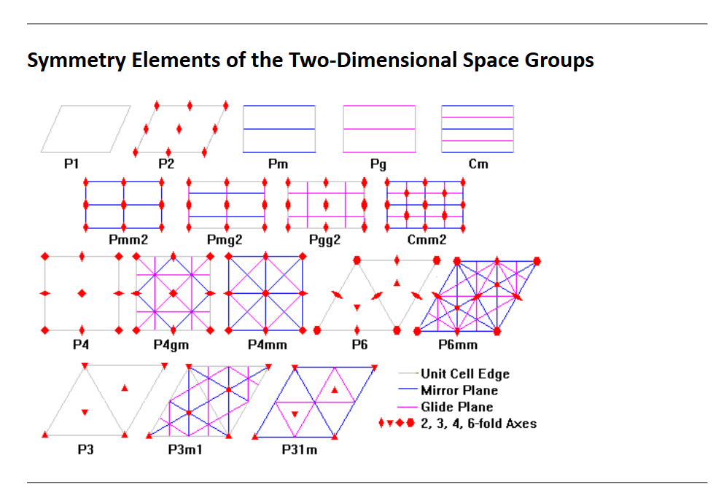

Symmetry  group | IUC  notation | Lattice  type | Rotation  orders | Reflection  axes
1 | p1 | parallelogrammatic | none | none
2 | p2 | parallelogrammatic | 2 | none
3 | pm | rectangle | none | parallel
4 | pg | rectangle | none | none
5 | cm | rhombus | none | parallel
6 | pmm | rectangle | 2 | 90°
7 | pmg | rectangle | 2 | parallel
8 | pgg | rectangle | 2 | none
9 | cmm | rhombus | 2 | 90°
10 | p4 | square | 4 | none
11 | p4m | square | 4 ⁺ | 45°
12 | p4g | square | 4 * | 90°
13 | p3 | hexagon | 3 | none
14 | p31m | hexagon | 3 * | 60°
15 | p3m1 | hexagon | 3 ⁺ | 30°
16 | p6 | hexagon | 6 | none
17 | p6m | hexagon | 6 | 30°
+ = all rotation centers lie on reflection axes
* = not all rotation centers on reflection axes

Sources: http://www.uwgb.edu/dutchs/SYMMETRY/2DSPCGRP.HTM
https://www2.clarku.edu/faculty/djoyce/wallpaper/seventeen.html

Glide planes and screw axes are indistinguishable in plane lattices. By convention glide planes rather are used rather than screw axes.

